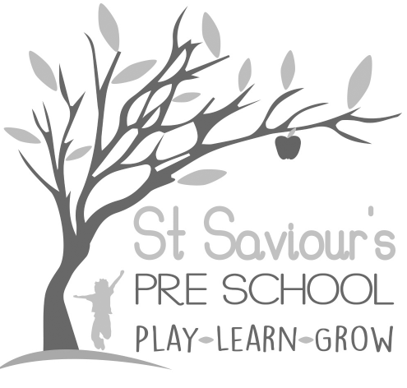

10.3a CHILDREN’S RECORDS

Written by: Claire Toms and Tina Alder Date: 1.09.22 – reviewed 31.8.25

Policy Statement
We have record-keeping systems in place that meet legal requirements; the means we use to store and share information is fully compliant with the UK General Data Protection Regulations (GDPR) (2018), the Data Protection Act (2018), the Human Rights Act (1998), and the Safeguarding and Welfare Requirements of the EYFS (2025).
This policy and procedure should be read alongside our Privacy Notice, Confidentiality Policy, Records Retention Policy, Information Sharing Policy, and Safeguarding & Child Protection Policy.

Procedures
We keep two kinds of records on children attending our setting:

1. Developmental records
- These include observations of children in the setting, photographs, samples of their work and summary developmental reports.
- These are kept in the setting and can be accessed, and contributed to, by our staff, the child, and the child’s parents.
- Progress is monitored and recorded via secure online platforms (Tapestry or equivalent, encrypted systems) and/or encrypted spreadsheets.
- Records are shared regularly with parents and carers in line with the EYFS 2025 requirement to engage families in children’s learning and development.

2. Personal records
These may include the following (as applicable):
- Personal details – registration form, consent forms, parental responsibility details, and authorised collectors.
- Contractual matters – including a copy of the signed parent contract, attendance records, a record of fees, invoices, reminders, or disputes about fees.
- Child’s development, health and well-being – including a summary of the child’s EYFS profile report, records of discussions with parents, and relevant health information.
- SEND/Early Support – including any targeted interventions (e.g. Individual Support Plans, Early Years SEND plans), observations, and records of meetings with parents or professionals.
- Welfare and child protection concerns – including safeguarding records, meetings, referrals, and follow-up actions. Records will comply with HCC Safeguarding Children Partnership procedures.
- Correspondence and Reports – including 2-Year Progress Check summaries, transition documents, multi-agency reports, and communication with external professionals.
Access and security:
- Access to children’s files is restricted to authorised persons: manager, deputy, designated safeguarding lead (DSL), the child’s key person, or other staff authorised by the manager.
- Records may be requested by Ofsted, HCC auditors, or other authorised safeguarding professionals.
- Parents/carers can access their child’s personal files but will not have access to information relating to any other child.
- Staff are trained on confidentiality during induction and reminded regularly through supervision.
- Children’s progress records are passed on to their next setting/school or returned to parents when they leave.
- Safeguarding/child protection records are kept in line with HCC guidance – up to the child’s 25th birthday. Accident/incident records are retained until the child reaches 21 years.
- All records are kept securely in locked cabinets and/or password-protected systems.

Archiving Children’s Files
- Developmental records are forwarded to the next setting or returned to parents when the child leaves.
- Personal and safeguarding records are archived securely in line with HCC retention schedules.
- Records of children subject to safeguarding concerns are stored in sealed envelopes with child’s details and date of leaving, archived securely for the statutory retention period.
- Financial information is stored and destroyed in accordance with our finance and audit procedures.
- Daily records of attendance (registers) are kept securely in line with EYFS 2025 attendance requirements.

Legal Framework
- UK General Data Protection Regulation (2018)
- Data Protection Act (2018)
- Human Rights Act (1998)
- Children Act (1989; 2004)
- Statutory Framework for the Early Years Foundation Stage (EYFS 2025)
- Working Together to Safeguard Children (2023)
- HCC Record Keeping and Retention Guidance for Early Years Providers

